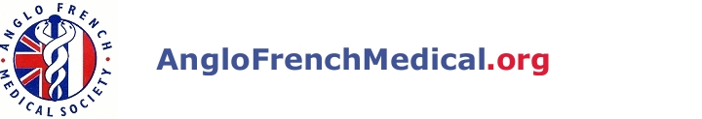
Medical French
The 20th Annual Residential Course

Topics to be covered include:
- How to take a history and examine a patient in French
- How to survive on ward rounds and in clinics
- Talking to patients, relatives and colleagues
- Investigations: ECG, X-rays, blood tests, etc.
(how to request, chase up, interpret and talk about them)
- French General Practice
- Practical procedures, emergencies

Extensive course handbook provided
All levels of French-speaking accommodated

Friday evening 23rd March to Sunday lunchtime 25th March 2012
Conference Park, University of Warwick

- Full residential fees, including gala dinner are £375 for doctors and £150 for students (an upgrade from standard to superior accommodation is available for an extra £120).

Christine Greenwood, School of Clinical Sciences, Clinical Sciences Centre, University Hospital Aintree, Longmoor Lane, Liverpool L9 7AL.
Email: c.greenwood@liv.ac.uk Tel: 0151 529 5885 Fax: 0151 529 5888

To Book Contact

